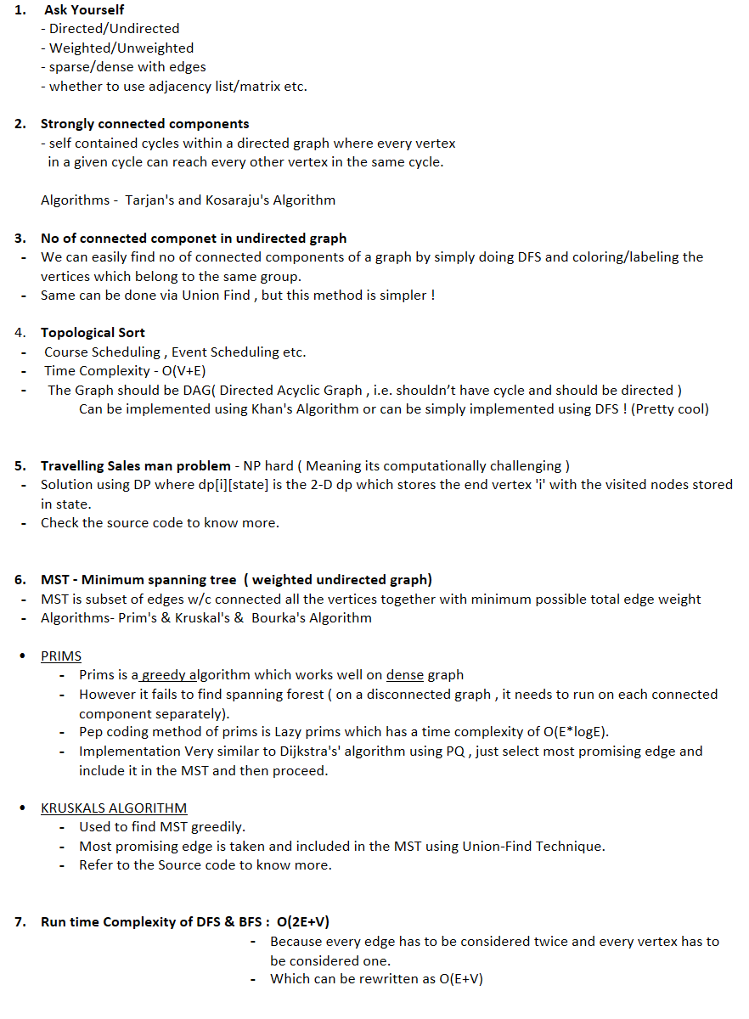
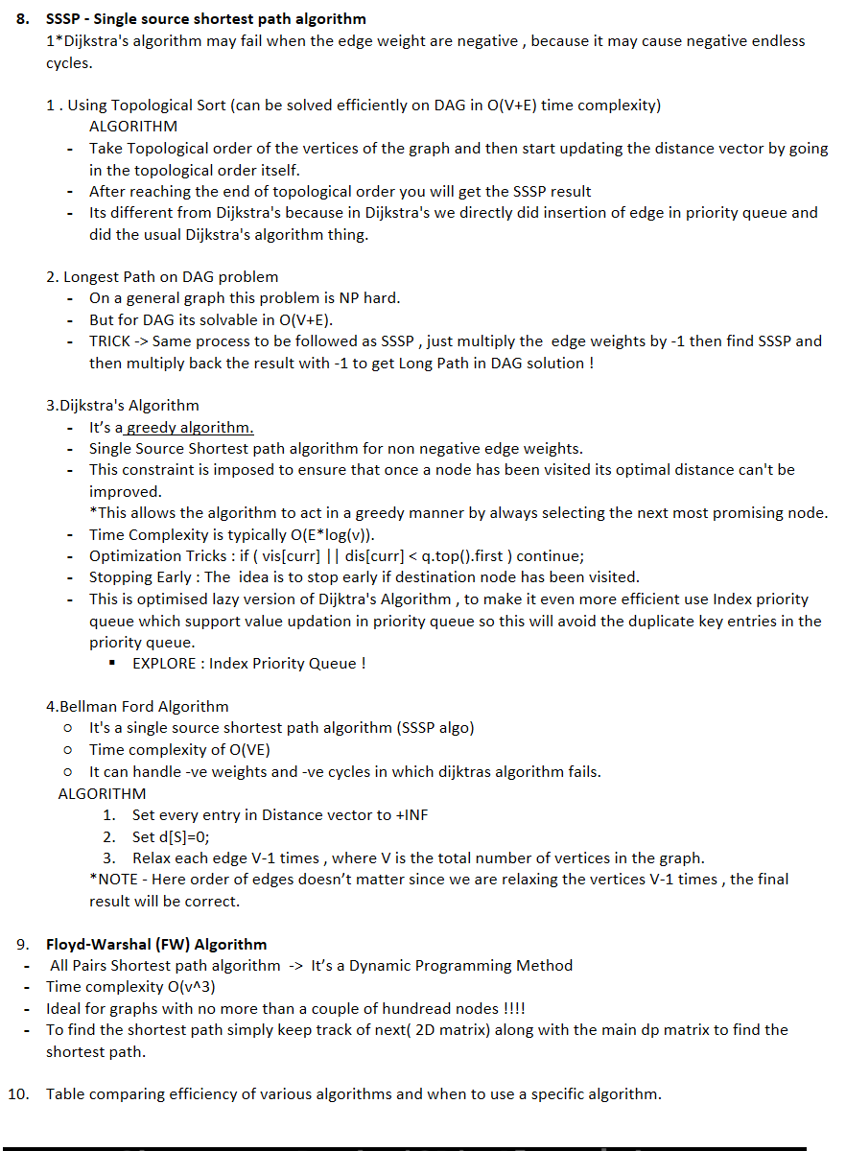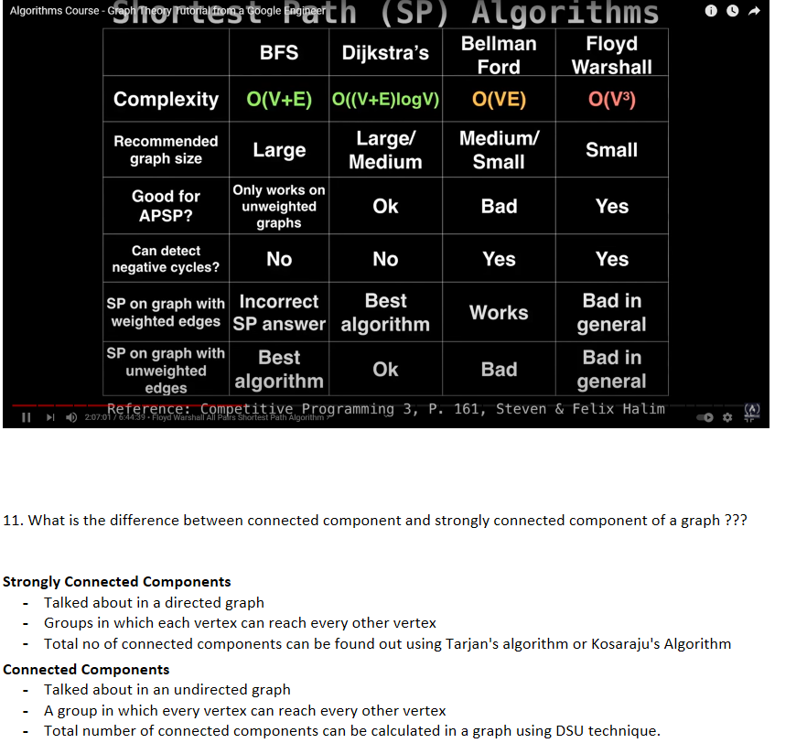

  - Tarjan's Algorithm
  - For finding the connected component in a directed graph.
  - Works on Low link values ( Value of the index of lowest node which can be reached via the current node )
  - We cant simply calculate the no of strongly connected components by grouping nodes with same low link values because these values are dependent on the order in which DFS is performed.

  - ALGO
1.Thus tarjans algo copes with random traversal order of DFS by maintaining a stack of valid nodes.
2.Nodes are added to stack as they're explored for the first time.
3.nodes are removed from the stack each time a complete SCC is found.
4.Since its based on DFS thus the run time complexity is O(V+E)
  - Bridges and Articulation Point **** In an Undirected Graph****

  - Bridges and articulation point have very similar algorithm
  - They are used to find the weak point or point of failure in a network
  - Removal of a bridge causes increase in the no of connected component in a graph.
  - Algorithm for finding bridges can be extended to find articulation point in a network
  - Bases on comparison of low link values with discovery time (ids) value

  - Condition for bridge
If(ids[u]<low[v]) then it’s a bridge.

  - Condition for articulation point
If(ids[u]<=low[v]) then its an articulation point
**Note here we need to check and ensure if the root node of the connected component is an articulation point explicitly

  - Check the source code for these to algorithms to know more !



 | Uses of DFS  MST  Find Cycles  Check if graph is Bipartite  Strongly connected components of a graph  Topological Sort  Find Bridges and articulation Point  Augmenting path in a flow network  Generate Mazes  And many more application !!!!! |  | Uses of BFS  Dudgeon Escape Problem
Video Reference : Algorithms Course - Graph Theory Tutorial from a Google Engineer



